PRAS Accounts Payables
Auto Invoice – (VMI PO)
Manual (R12)

Client:
Shared Service Center
Finance and Accounting Department

Author:
Creation Date: January 8, 2015
Last Updated: January 8, 2015
Control Number and Version are marked by a Word Bookmark so that they can be easily reproduced in the header and footer of documents. When you change either of these values, be careful not to accidentally delete the bookmark. You can make bookmarks visible by selecting Tools->Options…View and checking the Bookmarks option in the Show region.

PROCEDURE DETAILS

Log in into Oracle Application r12 using your Username and Password

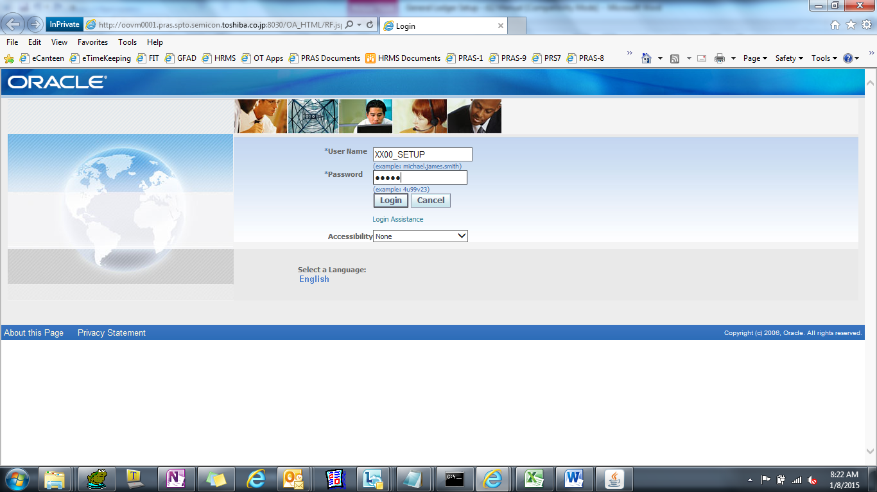

Select TIP AP Add On Systems Responsibility

Check PO
(N)

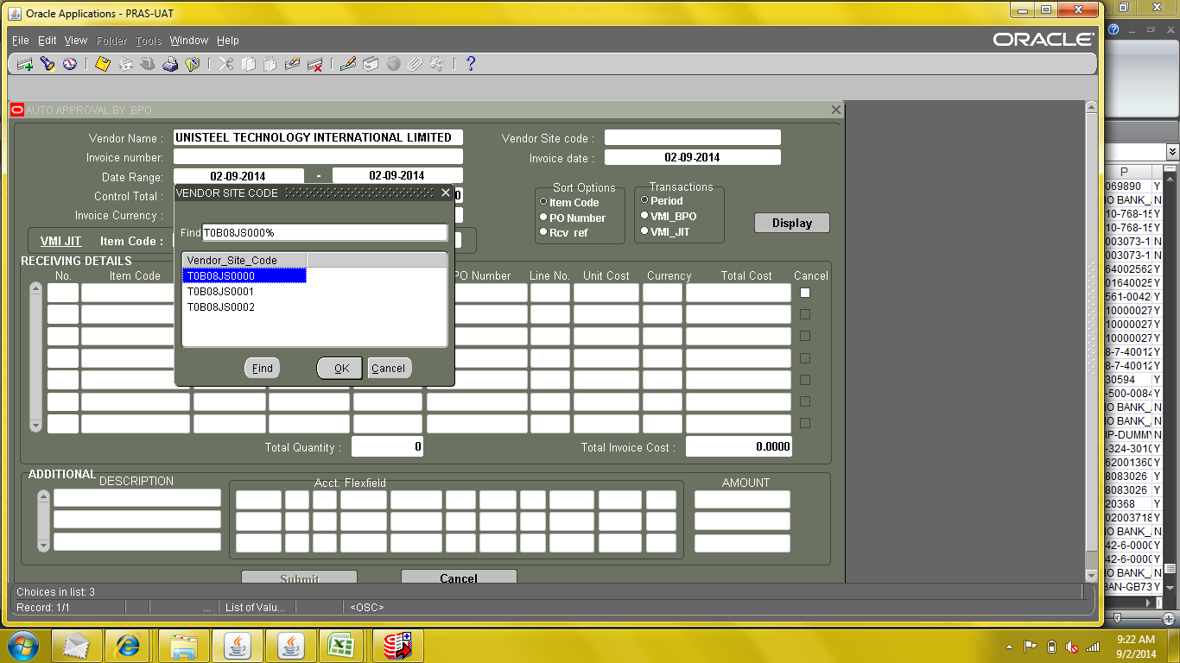

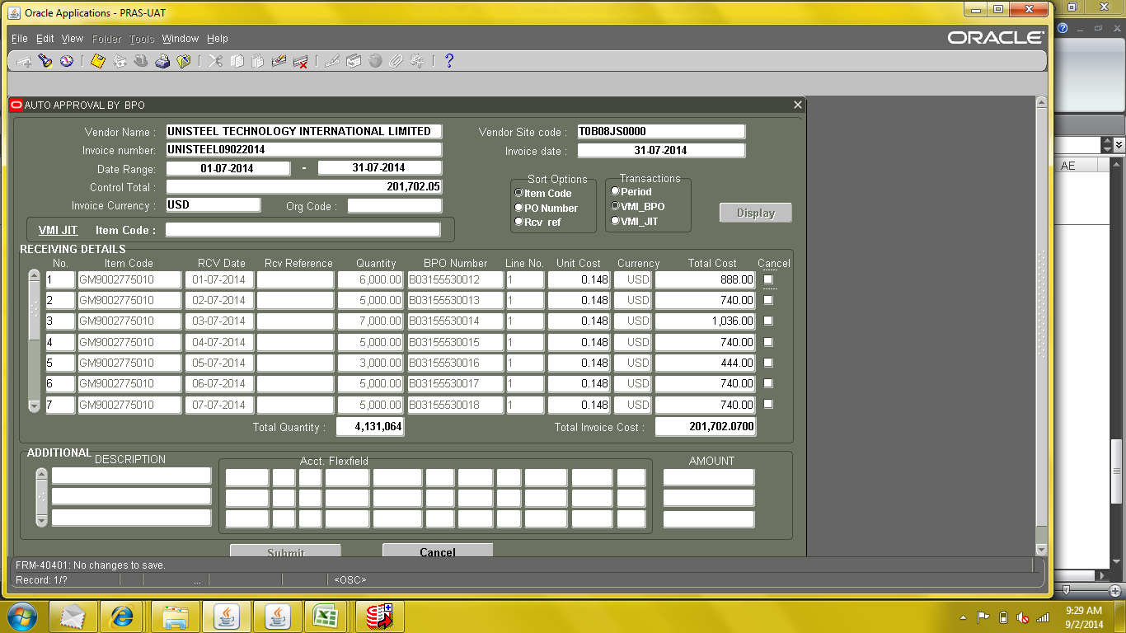

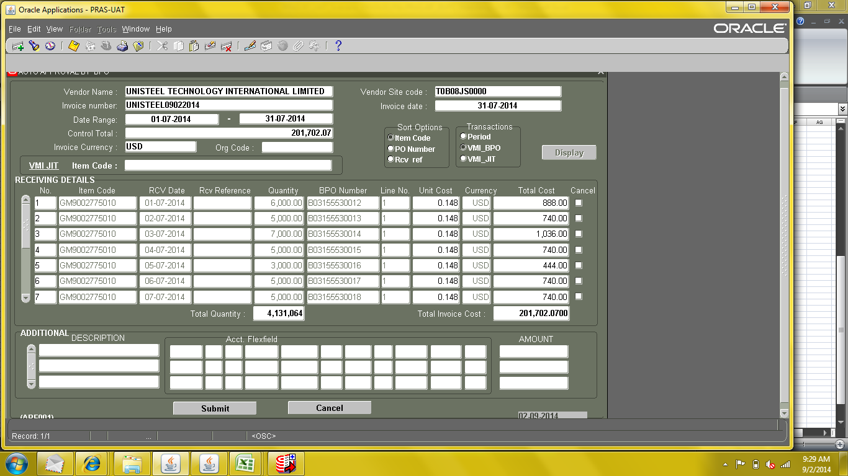

Execute Payables Open Interface Import

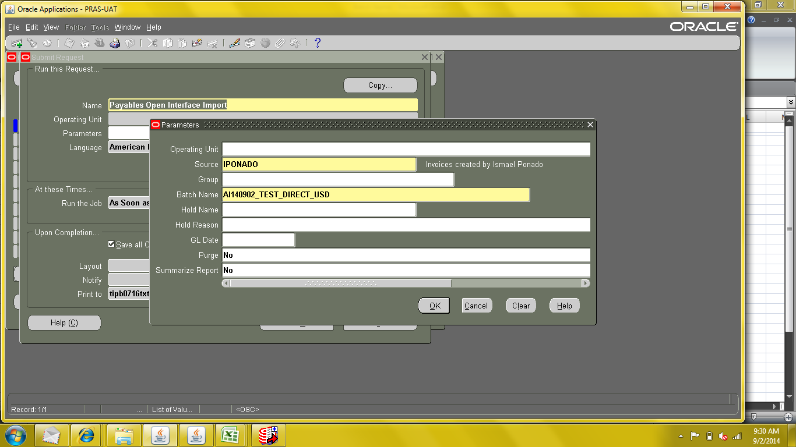

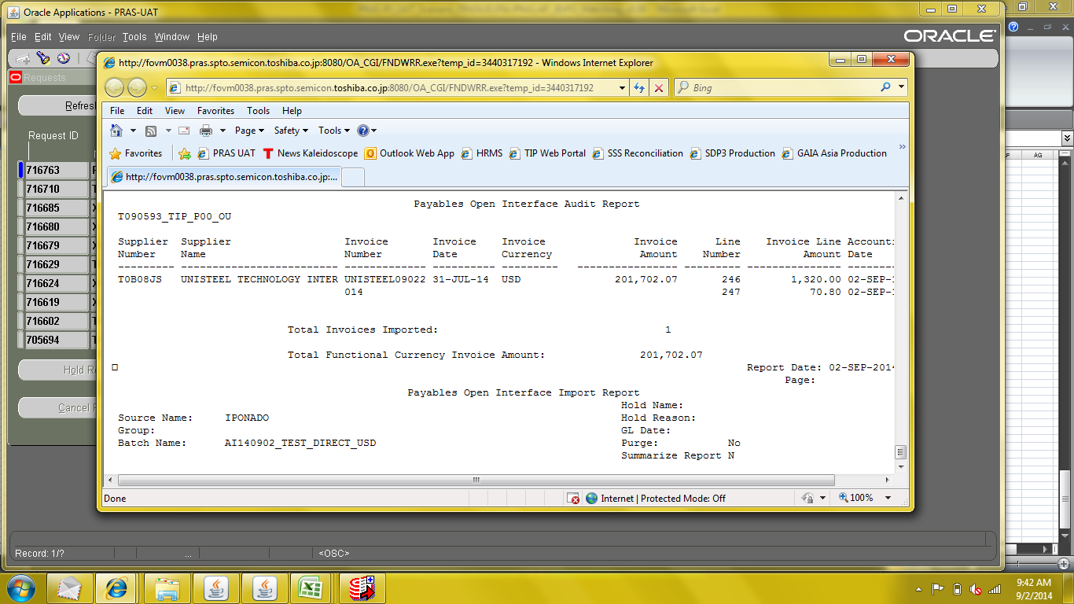

Check Created Invoice Batch

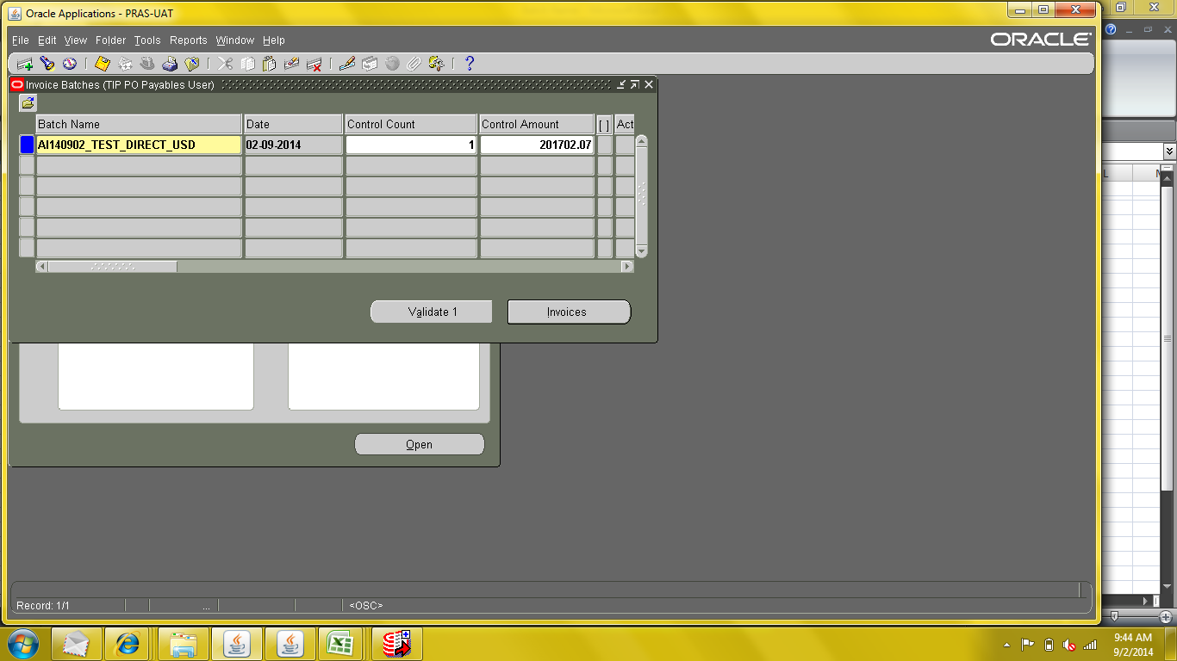

Check Created Invoices
Check Lines and Distributions

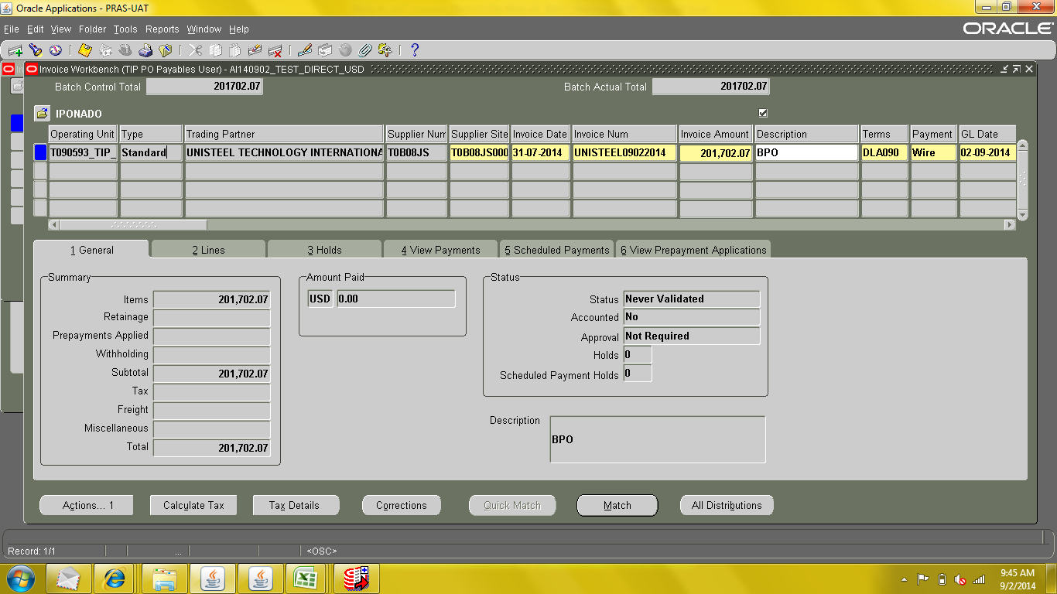

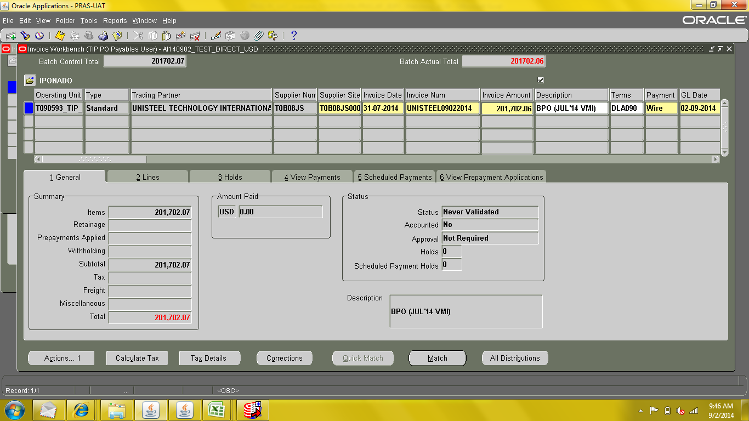

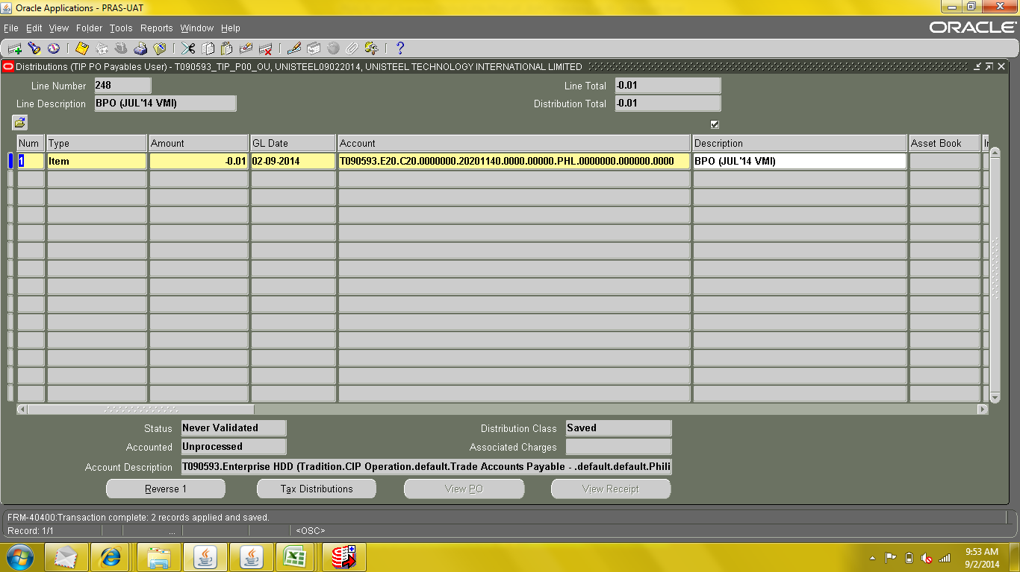

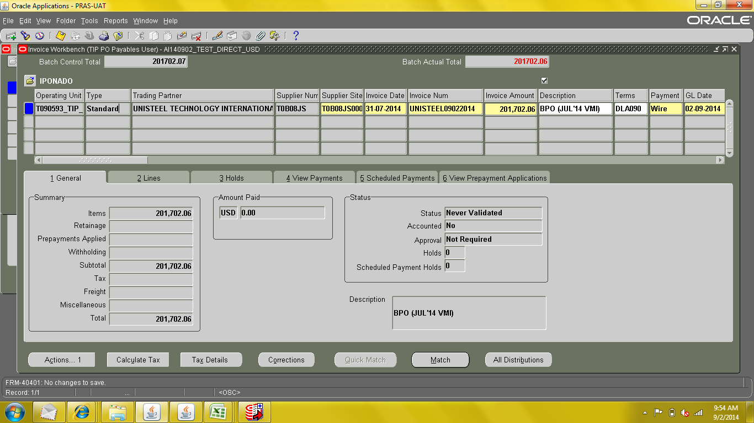

Invoice Validation

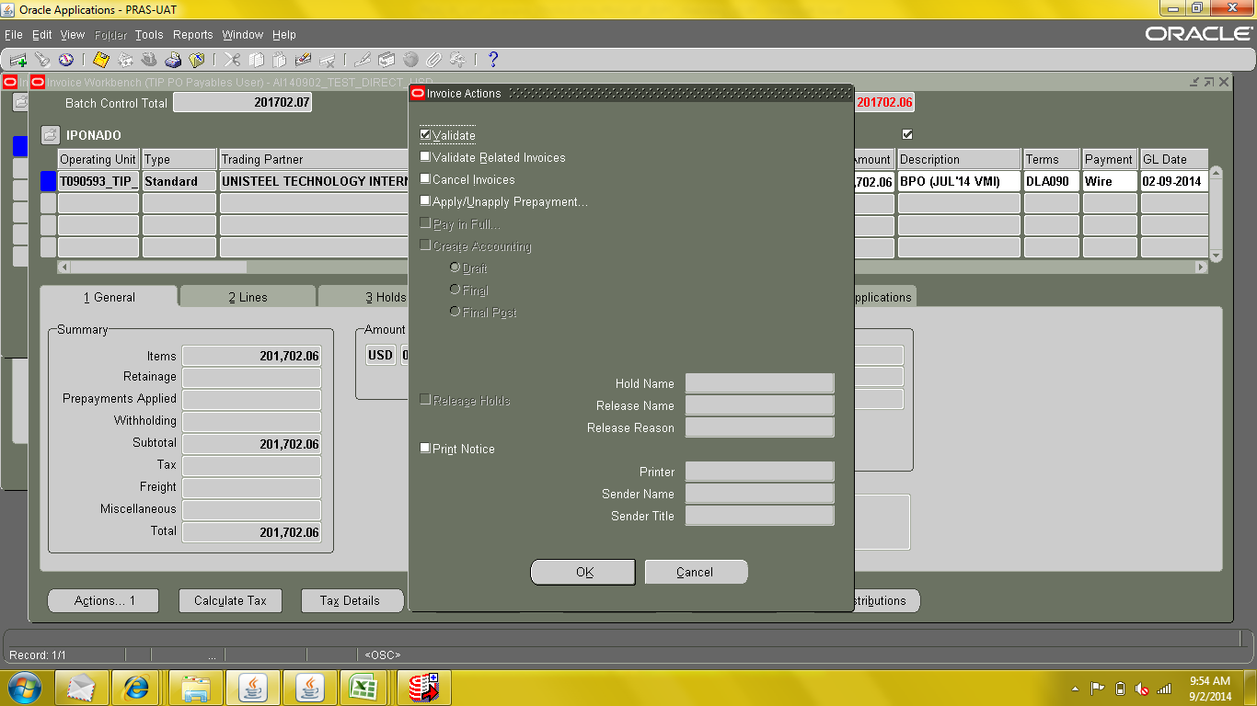

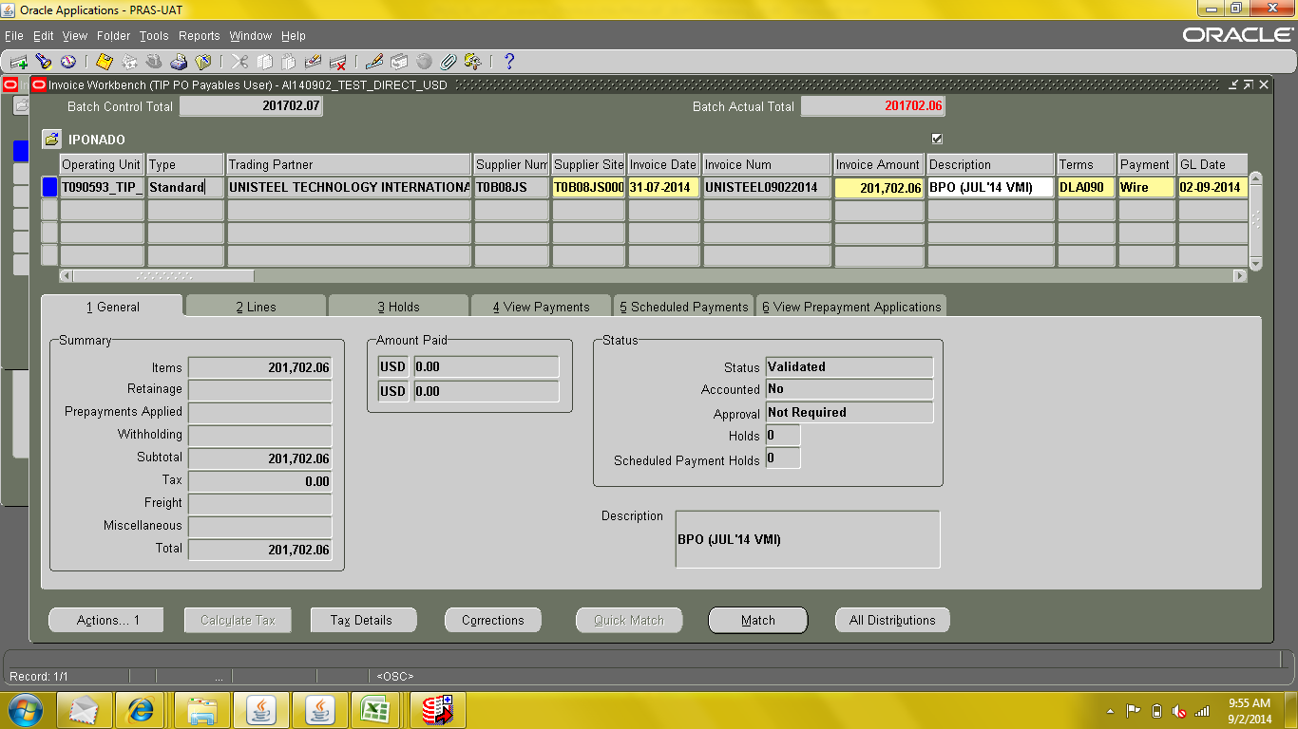

Invoice Create Accounting

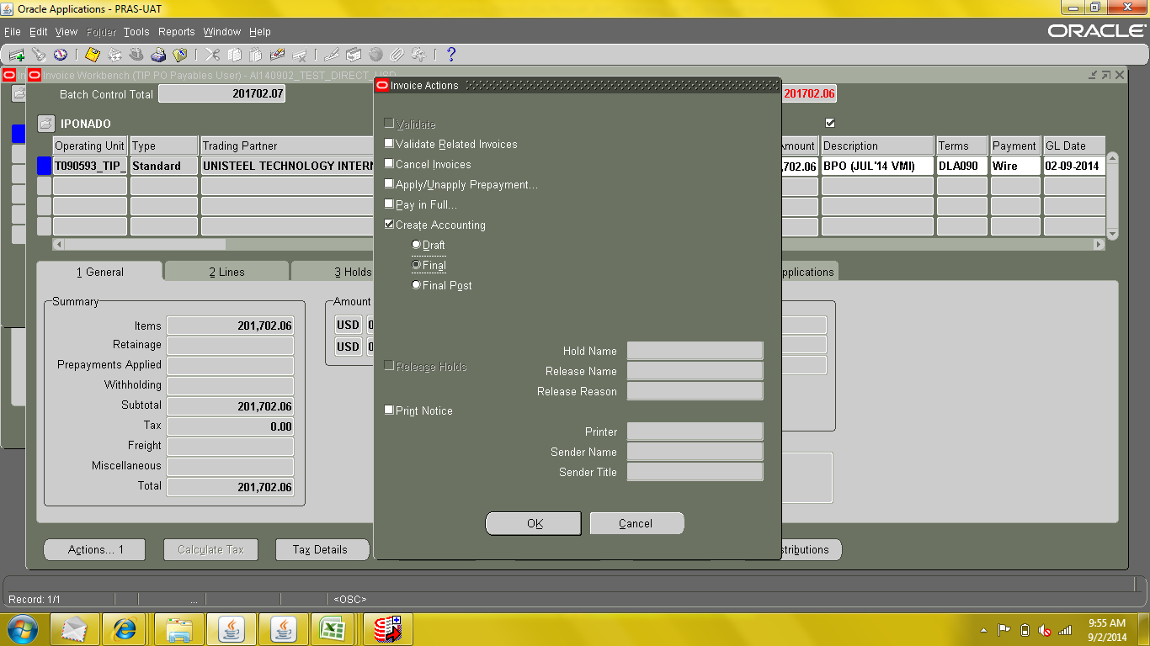

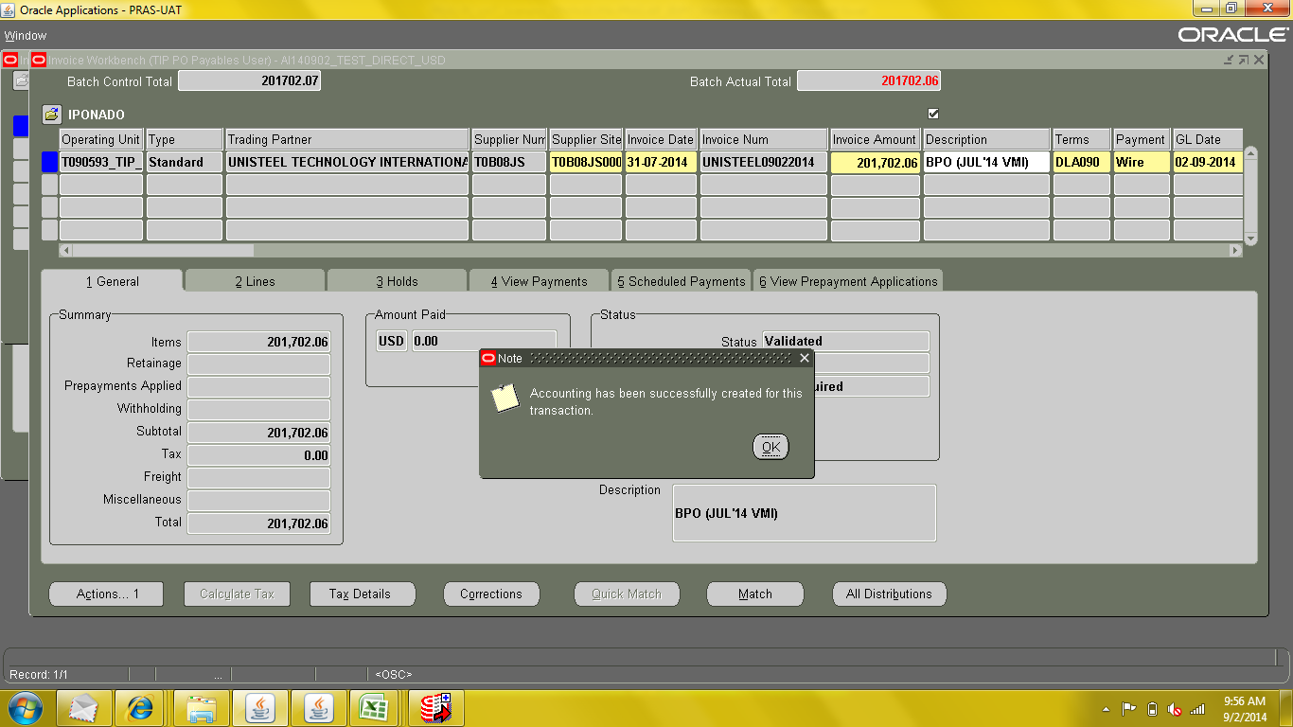

Run TIP Approved Invoice Transmittal
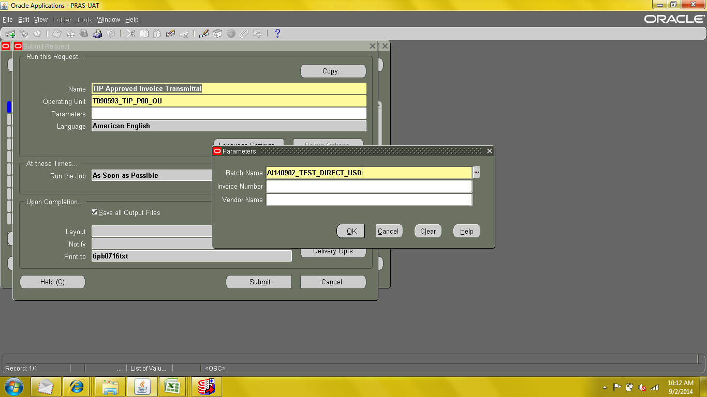

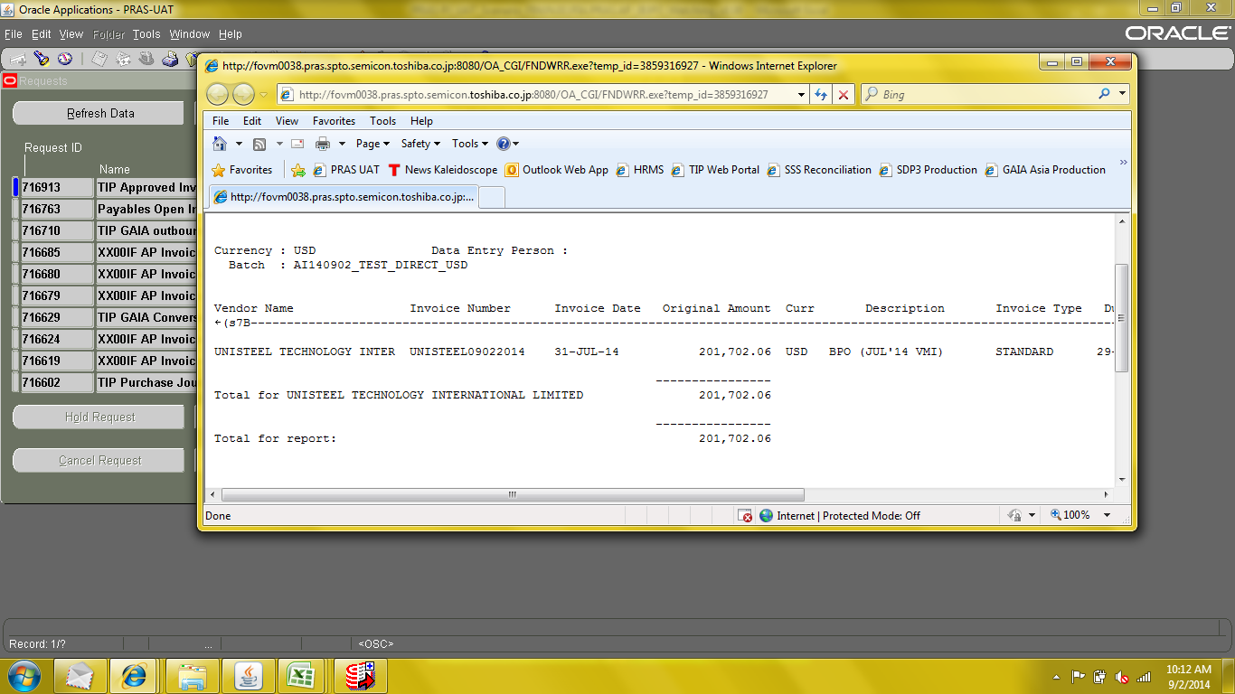

>> Proceed with GAIA Interfacing.

